HOME
**Need spelling/sentence correction:

Free Demo Session
The forst demo session if FREE for all interested participants!
The first demo session is FREE for all interested participants!

- Certification under the Tai Chi Federation of India
A recognized certification that validates proper training and learning standards.

- Join Now! Button is not redirecting to Contact page.

ABOUT US
- Join Now! Button is not working

YANG STYLE TAICHI

Six Generations of Yang Style Tai Chi
Second and third generation names and their details are incorrect.. Correct the name as per below image.
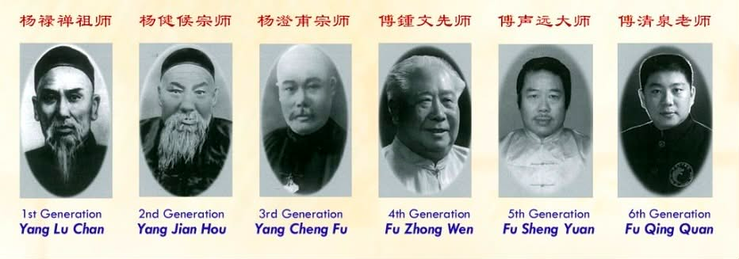

Join Now! Button is not working

GALLERY
- Add below attached photos under Practice tab
  - Img_6033
  - img_6196
  - Img_6066
  - img_7773
- Add below attached photos under Event tab
  - Img_7771
  - img_7772

COURSES
Correction:

Advanced Course
Duration: 1 Year

Course Comparison Overview

Advanced Course | 1 Year

CONTACT

